Name __________________________
Period _______ Date ______________

Science 20 Workbook
Lesson 1.1: Introduction & Average Speed

- Write the definition of uniform motion, non-uniform motion, average speed & instantaneous speed in the box below. Provide an example of each.
Uniform motion: motion in a straight line with a constant speed

Non-uniform motion: motion that changes direction or speed or both

Average Speed (v) – change in distance in a period of time

Instantaneous speed (v) – speed at one moment of time

- Open your Science 10-20-30 Data Booklet to page 2 and look under "Kinematics & Dynamics Formulas". Write the formula for speed & explain what each symbol stands for with units.

v= d v=speed (m/s or km/h); d = distance (m or km)
v t = time (s or h)

- Convert the following into seconds:
  - 90.0 min x 60 = 5400s b. 30 hours x 3600 = 108000s
BONUS: 17 years x 365 x 24 x 60 x 60 = 536112000s
- Convert the following into meters per second or meters:
  - 628 km/h x 1000/3600 = b. 285 km x 1000 = 285000
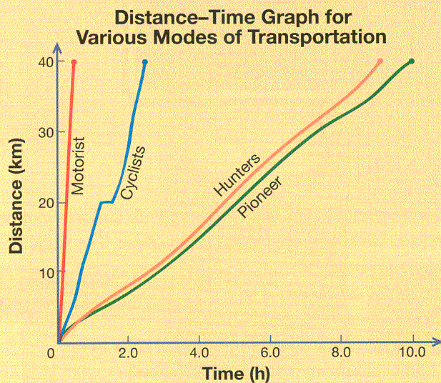
Average speed
Example Problem 1.1: Using the graph to the right, determine the average speed of the cyclists.
Step 1: d = ______; t = _____; v = ______
Step 2: v = ________ / _______
Step 3: v = ________
Step 4: the cyclist’s average speed was ______
1a) What is the average speed of the motorist?

- What is the average speed of the hunters?

- What is the average speed of the pioneers?

2. Which of the four travelers stopped?
    - Which of the four travelers traveled at the most uniform speed?
    - Describe an object that is traveling at uniform speed.
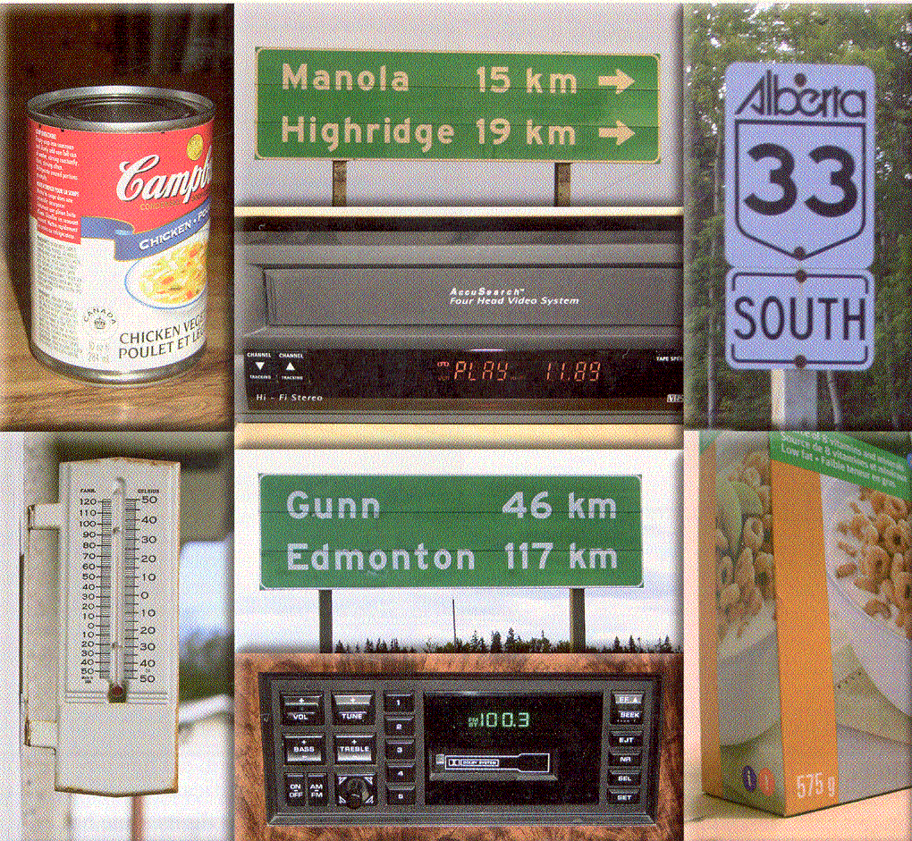
- Place a S on the pictures that show scalar measurements. Place an V on the pictures that show vector measurements.

Conversions:
Example Problem 1.2: An owl is able to drop 1.30m in 0.80s to capture its prey. Determine the owl’s average speed in m/s and km/h.

- David drives his quad 20.5 km into the back country to get to his favorite lake to fish for trout. If it takes 2.5 h to get to the lake, determine his speed in km/h & m/s.

- The sound waves from a thunderclap can travel 20.6 km in 1.0 min. Determine the speed of sound in meters per second.

- During a track meet, Kelsey ran the 80 m hurdles in 12.2 s. Determine Kelsey’s average speed in m/s and km/h.
V=d/t; v=80/12.2 = 6.6m/s
6.6 m/s x 3.6 = 24 km/h

APPLICATION:
A person is traveling down a straight section of level highway at a constant speed.
  - What is the type of motion demonstrated by the car?
uniform
  - What measurement does the speedometer display?
Speed (km/h)
  - A RCMP plane determines that the person travels 250m every 10.0s. What is the person’s average speed in m/s?
V=d/t; v=250m/10.0s = 25.0 m/s

  - What is the average speed in km/h?
25.0m/s x 3.6 = 90.0 km/h

  - What can be concluded about average speed and instantaneous speed, when an object is traveling at uniform speed.
Average speed and instantaneous speed are the same when traveling at uniform speed.
Lesson 1.2: Solving Problems & Manipulating formulas
Example Problem 1.3: During a sneeze, a driver’s eyes can be closed for about 0.50s. If the vehicle is moving at 100 km/h, what is the distance traveled during the sneeze.
d=vt; 100 km/h x 0.2778 = 27.7777… m/s
d=27.777m/s x 0.50s = 14 m

Example Problem 1.4: While traveling in the dark, halogen headlights allow a person to see 60 m ahead. If the person is traveling 70 km/h, how many seconds will it take to reach the edge of headlights?
t=d/v; 70km/h x 0.2778 = 19.446…m/s
t= 60m/19.446… = 3.1 s

- Dana reaches for a CD and takes her eyes off the road for 2.0s. Determine her distance if her car was moving:
  - 30 km/h (school zone)x 0.2778 = 8.333…m/s
d=vt

d=17m

  - 50 km/h (residential)x0.2778 = 13.89…m/s

D=28m
  - 80 km/h (gravel)

D=44m
  - 110 km/h (divided highway)

D=61m
- Look at your answers in question 9). Why is speeding so dangerous?
- How long does it take to drive 439 km between Edmonton & Fort McMurray if an average speed of 95 km/h is maintained?
t=d/v

- A tuna can swim an average speed of 30 km/h. How long would it take to swim 5000 km across the Atlantic Ocean?

- North America plate drifts away from Europe at 25mm per year (_______ m/s). If a human hair is 5.0 x 10-5 m thick, how long would it take before Nova Scotia is a “hair’s thickness” farther from England?

APPLICATION:
During the 2002 Olympic Winter Games, Catriona Le May Doan won gold for her two 500 m speed skating trials with a combined time of 74.75s.
- What was Catriona’s average speed for her two trials?

- If the skaters race around an oval track, where do the skaters travel at a non-uniform speed?

- Special suits have reduced Catriona’s time by 0.15s. Using her average speed, determine the distance Catriona traveled during this 0.15s.

- Track athletes run 400 m in under 50s. Using her average speed, determine how many seconds it would take Catriona to skate 400 m.

Lesson 1.3: Average Velocity
Please define the following terms and provide an example of each:
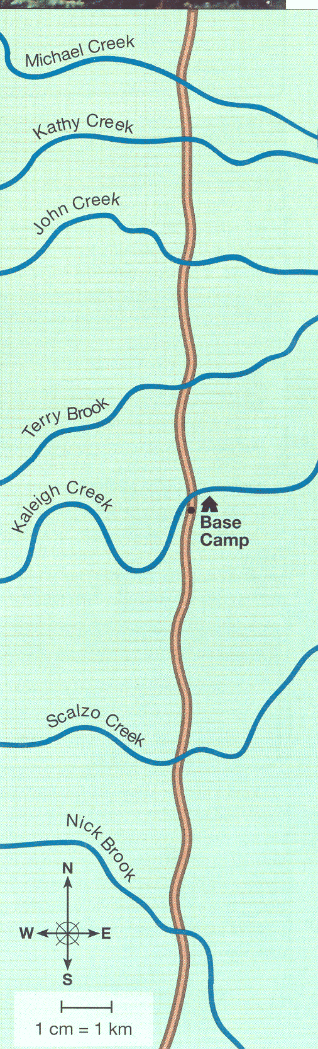
Scalar:

Vector:

Displacement:

Average velocity:

Resultant in head to tail method:

Position
Example Problem 1.5: Use the map, scale to the right and a ruler to solve the following problems:
- If Melissa and Usha are 5 km from base camp, where could Melissa and Usha be?

- What other information is necessary to locate Melissa and Usha?

- Using the map & scale to the right, describe the campers position from base camp using N & S convention AND sign convention for each of the following:
  - Terry Brook: ____________ AND__________
  - Kaleigh Creek; ___________AND ___________
  - Nick Brook crossing: ____________AND ________
Displacement:
Example Problem 1.6: Determine the displacement from Michael creek to Nick Brook

- Using the map & scale to the right, determine the displacement using N & S convention AND sign convention, for each of the following:
  - Scalzo Creek to Terry Brook: _______AND ______
  - Nick Brook to John Creek: ________AND _______
  - Kathy Creek to Terry Brook: _______AND_______
  - Base camp to Michael creek back to Terry Brook: _________AND __________
- Compare your answers from 14 a and 15 d. Why are they the same.
Average Velocity:
Example problem 1.7: If Raj travels along the trail from John Creek to Nick Brook in 3.5 h, what is Raj’s average velocity in km/h?
v=d/t; v=13.5km [S]/3.5h = 3.9 km/h [S]

Example problem 1.8: Melisa leaves Nick Brook and travels along the trail at 2.50 m/s [N] for 1.25 h.
- Calculate Melissa’s displacement.
11.3 km [N]

- Using the map to the right and a ruler, put an X where Melissa stopped.
Example problem 1.9: Usa and Melissa traveled from Kathy creek to Nick Brook in 2.25h. They stayed at Nick Brook for 1.75 h before heading to Michael Creek in 3.00h.
- Determine the girls’ average speed & average velocity.
Average speed | Average velocity
4.74 km/h | 0.170 km/h [N]
- Why are the values different?
Distance and displacement are different
- Because fish weren’t biting at Scalzo Creek, the gang traveled north for 2.5 h to try their luck at John Creek. They stayed their for 3.0 h and then returned to base camp in 1.5 h. t= 7.0 h
a) Determine the displacement from Scalzo Creek to John Creek & the displacement John Creek to base camp
9.5 km [N] and 8.0 km [N]
b) Use the head to tail method & sign convention method to determine the resultant displacement

d) Calculate the average speed & average velocity.
Average speed | Average velocity
1.4 km/h | 0.78 km/h [N]
- Melisa and Ulsha leave Terry Brook with an average velocity of 4.0 km/h [S]. If they traveled for 2.75 h, calculate their displacement.

APPLICATION:
Use the map below to answer the questions that follow:
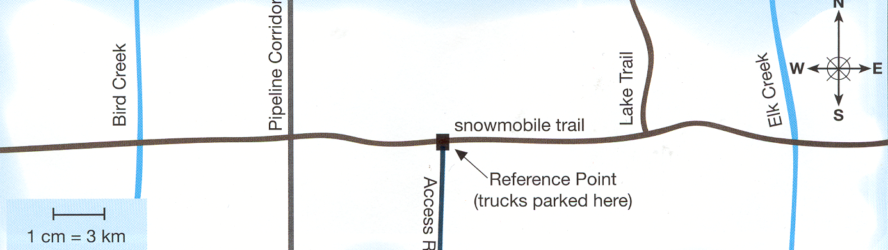
- Determine the position of the following using E & W convention AND sign convention.
- Reference Point to Bird Creek
- Reference Point to Elk Creek
- Reference point to pipeline corridor
- Reference point to start of Lake Trail
- Terry leaves the reference point and takes 0.75 h to travel to Bird Creek. Terry rests for 0.25 h before traveling 2.00 h to Elk creek. Determine Terry’s displacement using the head to tail method and sign convention method.

- Calculate the average speed and average velocity for Terry in question b).

- Monica leaves pipeline corridor and travels 1.75 h to Elk Creek. She rests for 0.75 h before traveling 2.5 h to Bird Creek. Determine Monica’s displacement using the head to tail method and sign convention method.

- Calculate the average speed and average velocity for Monica in question d).

- One snowmobiler left the reference point and traveled 24.0 km/h [E] for 30.0 min. Calculate the displacement and identify their location on the map.

Lesson 1.4: Graphical Description of Uniform motion
- What are the advantages of a computer stress model of the human eye during impact, for safety experts?

- Robot arms are used for microsurgery. Why is a microscope essential for surgery on the eye?
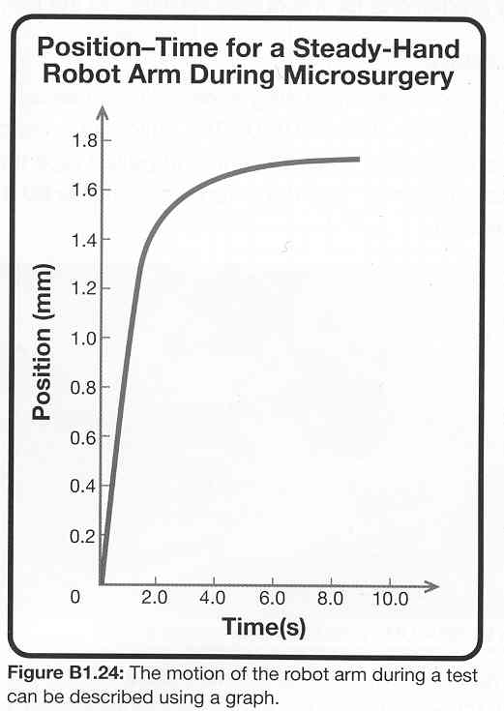
- Carefully examine the graph below of the robot arm from 0 to 1.0 s.
  - How would you determine the average velocity of the robot arm from the graph?

  - Determine the average velocity of the robot arm.

  - Sketch the velocity-time graph during the 1.0 s

- Carefully examine the graph above of the robot arm from 2.0 to 6.0 s.
  - Why does this part of the graph not describe uniform motion?

  - How is the robot moving during this time period?

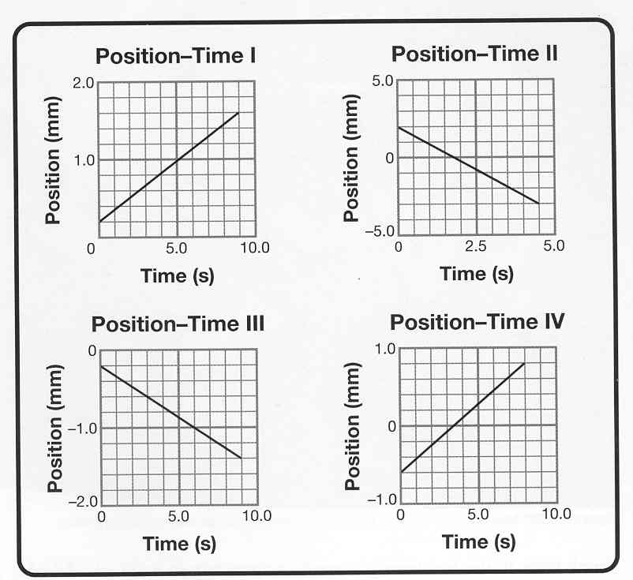
APPLICATION
The graphs below describe the motion of the surgical tool across the microsurgery track in terms of positions and times.
1.6
  - For each graph, describe its motion. Include the starting position, ending position and what direction the tool was moving (left or right).
.2
9
  - For each graph, calculate the average velocity.

Description of motion | Average velocity calculation
GRAPH I  Average velocity in a north direction. Position scale: 2/10 squares=0.2mm per square Time scale: 10/10squares= 1.0s per square Start at 0.2 mm End at 1.6 | v=slope = rise/run = (1.6 -0.2mm)/9.0s  1.4mm/9.0s = 0.16 mm/s (N)
GRAPH II  Constant velocity south  D scale: 5mm/5squares = 1 mm/square  T scale: 5s/10squares = 0.5s/square  Starts: 2mm and 0s  Ends: -3mm and 4.5s | Velocity = rise/run (mm/s)  V = (-3-2)/(4.5-0)  V = -5/4.5  V = -1.1 mm/s (S)
GRAPH III  Constant velocity south  D scale: 1.0/5squares = 0.2mm/square  T scale: 10s/10squares = 1s/square  Starts: 0.2mm and 0s  End: 1.4mm and 9s | Velocity = rise/run  V = (-1.4 - - 0.2)/9s  V = - 1.2mm/9s  V = - 0.13 mm/s (S)
GRAPH IV  Constant velocity north  D scale: 1mm/5squares = 0.2mm/square  T scale: 10s/10square = 1 s/square  Starts: -0.6mm and 0s  End s: 0.8mm and 8s | Velocity = rise/run  V = (1.4)/8  V = 0.175 mm/s

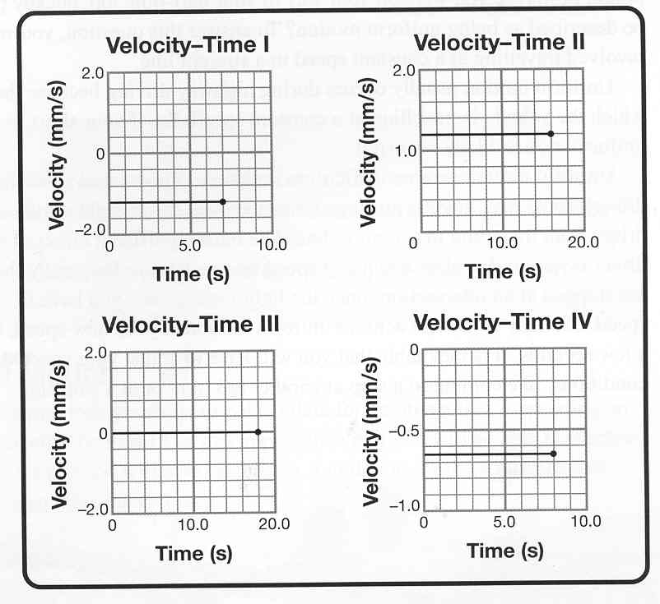
The graphs on the left describe the motion of the surgical tool across the microsurgery track in terms of velocity and time.
  - For each graph, describe its motion. Include how fast the tool was moving and what direction the tool was moving (left or right).
  - For each graph, calculate the displacement.

Description of motion | Displacement calculation

GRAPH I

GRAPH II

GRAPH III

GRAPH IV

Lesson 1.5: Graphical Description of Uniform motion
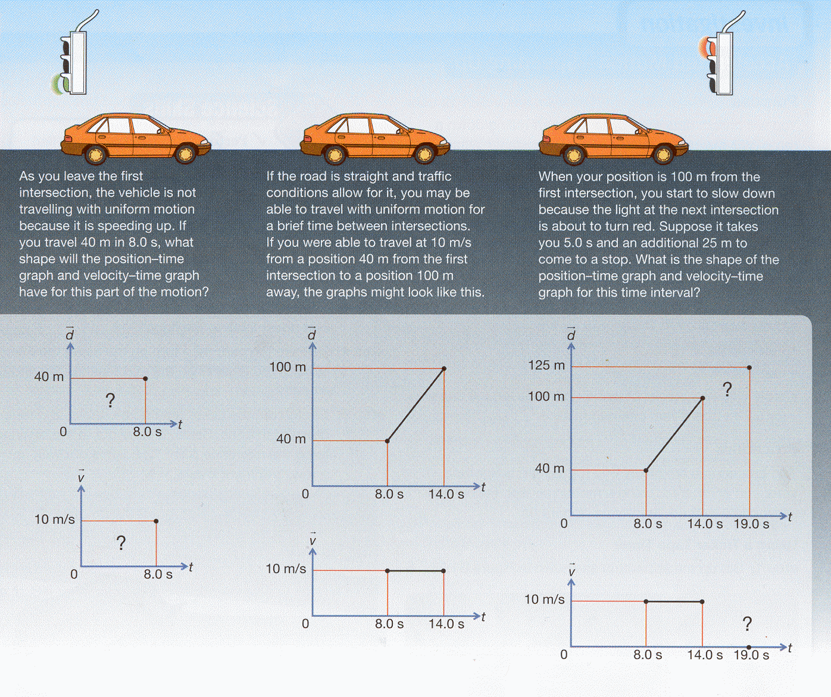
- Refer to the second set of graphs for the middle section of the motion, where a person is traveling with uniform motion.
  - Use the information of the position-time graph to verify with a calculation that the velocity was 10m/s during the period of uniform motion.
v = rise/run
v= (100m-40m)/ (14.0s-8.0s)
v= 60m/6.0s
v= 10m/s
  - Use the information on the velocity-time graph to verify with a calculation that you traveled 60m during the period of uniform motion.

d=length x width
d=10m/s x 6.0s
d=60m
Example Problem 1.10: Calculate the acceleration from the sample data displayed in the graphs below. Units for acceleration can be shown as cm/s/s or as cm/s².

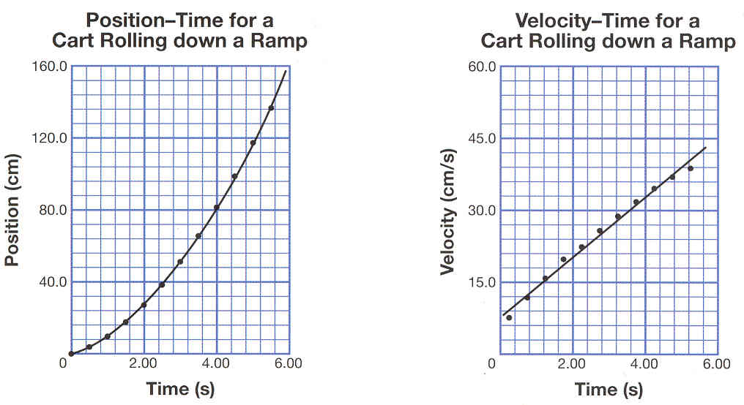
Velocity Scale = 15/5 = 3
Time Scale = 2/5 = 0.4

a=rise/run=velocity/time
a=(42-9/ (5.6-0.8)
a = 33m/s / 5.6s
42

to

9
a = 5.9cm/s

0to 5.6

- Determine the acceleration using the information provided by each of the following graphs.
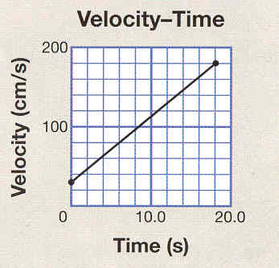
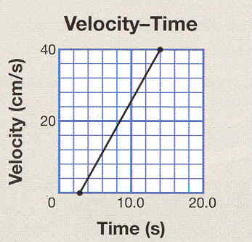
a. b.
v Scale = 100/5=20 v Scale=20/5=4
t scale = 10/5 =2 t scale = 10/5=2

rise =(180-80)=100 rise=(40-4)= 36
run (18-6) 12 run (14-4) 10

a= 8.3cm/s/s a = 3.6cm/s/s

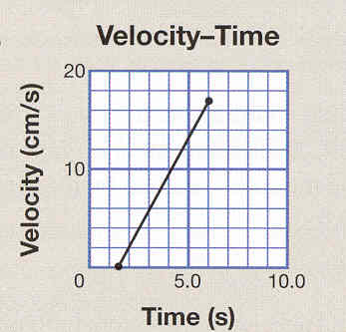
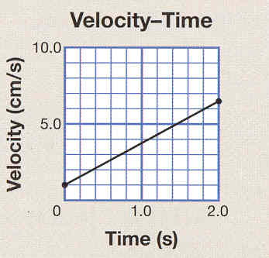
c. d.
v Scale = 5.0/5=1.0 v Scale=10/5=2
t scale = 1.0/5 =0.2 t scale = 5.0/5=1

rise =(6.0-1.0)=5.0 rise=(18-2)= 16
run (1.8-0) 1.8 run (6-2) 4

a= 2.8cm/s/s a = 4.0cm/s/s

Example Problem 1.11: A car traveling 70km/h east changed its velocity to 90km/h east in 4.5s. Determine the magnitude and direction of the average acceleration of the car in m/s².
v_{i} = 70 km/h [E] x 1000/3600 = 19.444…m/s;
v_{f} = 90 km/h [E] x 1000/3600 = 25 m/s [E]; t = 4.5s
a = (v_{f}-v_{i}) / t
a = (25m/s – 19.44.. m/s) / 4.5s
a = 1.2 m/s/s [E]

Example Problem 1.12: A sprinter on a high school track team can achieve an average acceleration of 3.0 m/s² from rest to his maximum velocity of 11.0 m/s.
- Calculate the time taken by the sprinter to reach his maximum velocity.
a = 3.0 m/s/s; rest = v_{i} – 0m/s; v_{f} = 11.0 m/s
t = (v_{f} - v_{i})/ a
t = (11.0 – 0 m/s) / 3.0 m/s/s
t = 3.7 s

- The coach explained during training that the sprinter can improve his performance if he can increase his acceleration during the first phase of the race. Even if his maximum velocity remained the same, a higher rate of acceleration would give him better results. Explain this thinking by referring to the calculation from part a.
If you increase the acceleration you decrease the time; the sprinter can reach maximum speed sooner.

Example Problem 1.13: A group of teens riding an inflatable tube start from rest and travel down a hill, accelerating at an average rate of 1.15m/s². Determine the speed reached by the teens after traveling for 6.0s.
Rest = v_{i} = 0 m/s; a = 1.15 m/s/s; t = 6.0s
v_{f} = v_{i} + at
v_{f} = 0 + 1.15m/s/s x 6.0s
v_{f} = 6.9 m/s down a hill

25. At a drag race, the dragsters start from rest and race down a course about 400m long. In one race, a competitor drove with an average acceleration of 30.8m/s², reaching a top speed of 500km/h at the end of the course, Assuming uniformly accelerated motion, determine the time it took the dragster to reach its top speed.
a = 30.8 m/s/s; rest = v_{i} = 0m/s; v_{f} = 500 km/h x 1000/3600 = 138.88…m/s
t = (v_{f} – v_{i}) / a
t = (138.88 m/s – 0 m/s ) / 30.8 m/s/s
t = 4.51s
Example Problem 1.14: Assuming the effects of air resistance are ignored, objects accelerate at 9.81m/s² downward when they fall through the air near Earth’s surface. This means that if a toy car falls from the flat roof of a five storey building, it would travel the 15 m distance in about 1.75s. Use the sign convention of down being the negative direction and up being the positive direction as you answer the next questions.
- If the car started from rest, determine the magnitude and direction of the car’s final velocity after 1.75s (just before touching the ground). State your answer in metres per second and kilometers per hour.
a = - 9.81 m/s/s; rest = vi = 0m/s; t = 1.75s
v_{f} = v_{i} + at
v_{f} = 0 + -9.81 m/s/s x 1.75s
v_{f} = 17.2 m/s
v_{f} = 17.2 x 3600/1000 = 61.9 km/h

- In this situation, the car was speeding up but the acceleration was negative. Sketch a graph of the motion to help explain how it is possible to have a negative acceleration in a situation where the object is speeding up.

26. A jet maintains an average acceleration of 2.20 m/s² for 36.0 s to reach the speed required for takeoff. If the jet starts from rest, determine its take-off speed in kilometers per hour.
a = 2.20 m/s/s; t = 36.0 s; rest = vi = 0 m/s
v_{f} = vi + at
v_{f} = 0 + 2.20m/s/s x 36.0s
vf = 79.2 m/s
vf = 79.2 x 3.6 = 285 km/h

27. Determine the acceleration from the information provided in each of the following graphs.
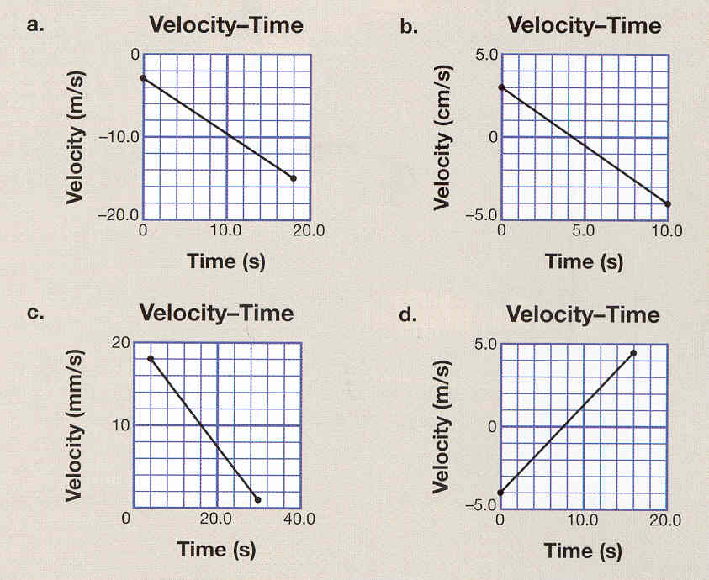
a. b.
v scale = -10/5 = -2 v scale = 5/5 = 1
t scale = 10/5 = 2 t scale = 5/5 = 1
a = rise = (-14 -- 6) = -8 = - 0.67 m/s² a = rise = (- 4 - 3) = -7 = - 0.70 cm/s²
run ( 16 – 4) 12 run ( 16 – 4) 10
c. d.
v scale = 10/5 = 2 v scale = 5/5 = 1
t scale = 20/5 = 4 t scale = 10/5 = 2
a = rise = ( 2 - 18) = -16 = - 0.67 mm/s² a = rise = (4 - - 4) = 8 = 0.50 m/s²
run ( 28 – 4) 24 run (16 – 0) 16

  - A motorist traveling on a highway at 100 km/h [N], sees a moose on the road and begins to brake. The vehicle stops 5.0s latter. Calculate the magnitude and direction of the acceleration of the vehicle.

  - Why do motorists take more caution when driving near the edge of a cliff, than when traveling down the highway even though the impact with an object is just as hazardous?
APPLICATION:
Refer to the velocity time graph to answer the following questions:

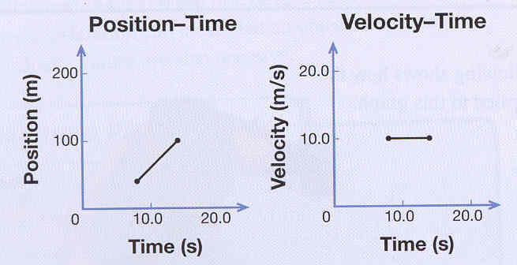
The car accelerates from rest and travelled 40 m in 8.0s with a final speed of 10.0 m/s. It travelled 60 m at a constant speed of 10.0 m/s for 6.0s. The car travelled 25 m in the last 5.0 s until it stopped at a red light

- Determine the acceleration of the car in the first 8.0 s.
Rest = v_{i} = 0 m/s; v_{f} = 10.0 m/s; t = 8.0s
a = (v_{f} - v_{i})/ t
a = (10.0 – 0 m/s) / 8.0s
a = 1.3 m/s/s

- Determine the acceleration of the car in the last 5.0 s.
v_{i} = 10 m/s; stopped = v_{f} = 0.0 m/s; t = 5.0s
a = (v_{f} - v_{i})/ t
a = ( 0 m/s – 10m/s) / 5.0s
a = -2.0 m/s/s

- The description of the motion states that the car traveled 40 m in the first 8.0 s. Use the values from the velocity-time graph to confirm that the displacement was in fact 40m. (Hint: Displacement is equal to the area under a velocity-time graph.).
d = area = (length x width)/2
d = (10 m/s x 8.0s) / 2
d = 80 /2
d = 40 m

- The description of the motion states that the car traveled 25 m in the last 5.0 s. Use the values from the velocity-time graph to confirm that the displacement was in fact 25 m.
d = area = (length x width)/2
d = (10 m/s x 5.0s) / 2
d = 50 /2
d = 25 m
Lesson 1.6: Calculating Displacement During Accelerated Motion

Use the following information from a driver training handbook regarding merging to answer questions 30 and 31.

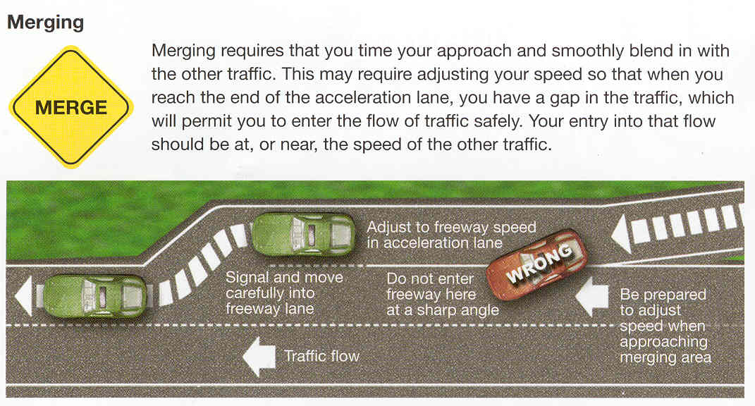

30. Why is the first lane you enter on a highway called the acceleration lane?

This is the lane where a person starts to speed –up or accelerate

31. The following graph represents typical data for a vehicle in an acceleration lane.
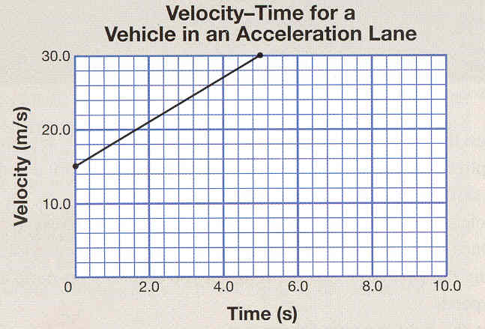
- Determine the initial velocity and the final velocity of the vehicle in metres per second and kilometers per hour.
Vi = 15 m/s; vf = 30 m/s

- Using the data on the graph, calculate the magnitude of the acceleration of this vehicle in m/s².
a = rise = (30 m/s – 15 m/s) = 15m/s = 3.0 m/s/s [left or E]
run (5s – 0 s) 5s

- If you were traveling in another vehicle that was underpowered, the acceleration could be less than the value you calculated in question 31.b. If the initial velocity and the final velocity were still the same, describe how the shape of the graph would be different.
The line would not be as steep and longer. (see graph on previous page)

- Explain why it’s important for the acceleration lane to be long enough to accommodate a wide range of possible vehicle accelerations.
Vehicles have engines with different accelerations. The lane needs to be long enough for the slowest engine.

32. A car enters the acceleration lane with an initial velocity of 65.0km/h [E]. The car reached a final velocity of 100.0km/h[E] in just 4.00 s. Calculate the displacement of the car in metres.
vi = 65.0km/h[E] x 1000/36000 = 18 .055… m/s
vf = 100.0km/h[E] x 1000/3600 = 27.77… m/s
t = 4.00s
d = [(18.055 + 27.777)/2] x 4.00
d = 91.66 d = 91.7m [E]
Example Problem 1.15: A baseball leaves a bat and travels straight up into the air, reaching its highest point 15.9m above the bat in just 1.8s.
- Determine the initial velocity of the ball using the displacement equation.
d=15.9m; t=1.8s; Vf=0m/s (stopped); Vi=?
2 x (Vf+Vi) = 2 x d/t
2
Vi=2(d/t)
Vi=2(15.9/1.8)
Vi=17.66666 Vi=18 m/s
- Verify your answer by calculating the initial velocity using the acceleration equation.
Vf-Vi=at
-Vi=-9.81x1.8
Vi=17.666s Vi=18 m/s
33. During a volleyball tournament, a player dives to prevent the ball from hitting the floor. The ball leaves the outstretched player’s arms with an initial velocity of 14.5m/s, directed straight up, and stops just below the ceiling, 10.7m above the player’s arms.
a) Calculate the time required for the ball to travel from the player’s arms to the ceiling using the displacement equation.
d=10.7m; vi=14.5m/s; vf=0m/s (stopped); t=?
t = d/ (Vf+Vi)
2
t = 10.7(14.5/2)
t = 1.4758s t=1.48s
b) Verify your answer by calculating the time using another equation.
t = (Vf-Vi)/a
t = -14.5/-9.81 t=1.478 t=1.48s

Example Problem 1.16: A car traveling 90 km/h accelerates at 0.50m/s² while passing another vehicle. If it takes 5.0 s to pass the vehicle, determine the distance traveled by the vehicle during this time.
vi=90km/h/3.6 = 25 m/s; a=0.50 m/s/s; t=5.0 s; d=?
d=ViT + 0.5 at²
d=25 x 5.0 + 0.5x0.50x5.0²
d=131.25
d=1.3 x10²m
Example Problem 1.17: Juanita leaves the surface of a trampoline with an initial velocity of 11.8 m/s, directed straight up. Determine the displacement of the gymnast after 0.80 s.
vi=11.8 m/s; t=0.80 s; a=-9.81m/s/s;
d=ViT + 0.5at²
d=11.8 x 0.80 + 0.5 x –9.81 x 0.80²
d=6.3 m
Example Problem 1.18: A diver steps off the edge of a platform and enters the water 5.0 m below. If the initial velocity of the diver was zero, determine the time it took for the diver to reach the water.
d=-5.0 m; a=-9.81 m/s/s; Vi=0 m/s
t²=d/(0.5a)
t²=-5.0/(0.5 x –9.81)
√t²= √1.0
t=1.0 s
34. A vehicle traveling 63 km/h[E] accelerates 1.0 m/s²[E] for 9.0 s. Determine the displacement of the vehicle during this 9.0 s time interval.
vi = 63km/h x 1000/3600 = 17.5m/s; a = 1.0m/s/s; t = 9.0s
d = vit + 0.5at²
d = 17.5 x 9.0 + 0.5 x 1.0 x 9.0²
d = 157.5 + 40.5 = 198m
d = 2.0 x 10²m

35. The driver of a vehicle traveling 84km/h on a country road is startled to see a deer standing in the middle of the road. By applying the brakes, the driver is able to slow down at a rate of -4.45m/s² while sounding the horn. Luckily the deer bolts before a collision occurred. Exactly 5.0s passes from the moment the rakes are applied to the instant the deer bounds from the road. Calculate the displacement of the vehicle during the 5.0 s time interval.
vi = 84km/h x 1000/3600 = 23.333…m/s; a = -4.45m/s/s; t = 5.0s
d = vit + 0.5at²
d = 23.333… x 5.0 + 0.5 x –4.45 x 5.0²
d = 116.66.. + -55.625 = 60.87m
d = 61m

APPLICATION: Use the following information to answer the questions below.
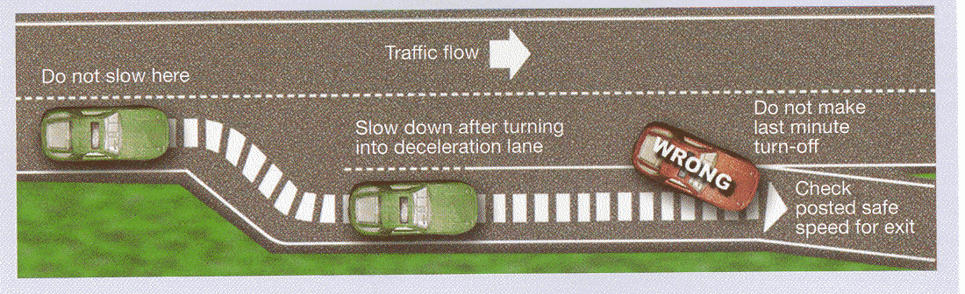
Suppose a vehicle enters the deceleration lane at 95.0km/h and must slow down to 50.0km/h before traveling around the curve of the exit ramp. Assume that most passenger cars take 5.00s to comfortably decelerate in this situation.
- Determine the vehicle’s deceleration.
Vi = 95.0 km/h x 1000/3600 = 26.388…m/s;
vf = 50.0 km/h x 1000/3600 = 13.888… m/s; t = 5.00s
a = (vf-vi)/t
a= (13.888 – 26.388m/s)/5.00s
a = -12.5/5
a = -2.50m/s/s
- Use the initial velocity, final velocity, and value for time to determine the displacement of the vehicle during the 5.00 s interval.
d = (vf+vi)/2 x t
d = (26.388… + 13.888…m/s)/2 x 5.00s
d = 100.69m d = 101m
- Use the initial velocity, value for time, and your value for the deceleration from question ‘a’ to calculate the displacement of the vehicle during the 5.00 s interval.
d = vit + 0.5at2
d = 26.388… x 5.00 + 0.5 x -2.50 x 5.0 2
d = 131.94 + - 31.25
d = 100.69 d = 101m
- Compare your answers to questions ‘b’ and ‘c’. Are they the same? What do your answers suggest about the minimum length of the deceleration lane for this case?
The answers are the same. The length of the lane should be more than 101 m
- If the highway were wet, a vehicle might only be able to manage a deceleration of 1.50 m/s² as it slows down from 95.0 km/h to 50.0 km/h. Determine the minimum length for the deceleration lane for this case.
d = vit + 0.5at2
d = 26.388… x 5.00 + 0.5 x -1.50 x 5.0 2
d = 131.94 + - 18.75
d = 113.19 d = 113m
- Compare your answers to questions ‘d’ and ‘e’. Explain why the total length of the deceleration lane would probably be designed to be more than 170m long for this exit.
Cars need a safe distance to slow down.

During a baseball game, a ball leaves a bat and travels straight up into the air. A TV camera records that when the ball reaches its highest point, it had traveled 18.5m from where it left the bat.
- Consider the part of the ball’s motion when it falls from its highest point back down toward the batter. Determine the time it takes the ball to travel this distance.
d=-18.5 m; a=-9.81 m/s/s; Vi=0 m/s
t²=d/(0.5a)
t²=-18.5/(0.5 x –9.81)
√t²= √3.7716
t=1.94 s
- Ignoring air resistance, when things travel through the air, their motion is symmetrical – the second half of motion mirrors the first half of motion. Use this idea to determine the time for the ball to travel from its release point on the bat to its highest point.
t = 1.94 s

- Use your answer to question ‘b’ to determine the magnitude and direction of the initial velocity of the ball immediately after it leaves the bat.
Vf = 0 m/s; a = 9.81m/s/s; d = 18.5m; t = 1.94s
DISPLACEMENT FORMULA ACCELERATION FORMULA
vi = 2d/t vi = a x t
vi = 2 x 18.5/1.94 vi = 9.81m/s/s x 1.94
vi = 19.07 vi = 19.03
vi = 19.1 m/s [up] vi = 19.0 m/s [up]
Lesson 1.7: Determining Stopping Distance

36. If someone were to drop a metre stick from rest, and then you grabbed it between your forefinger and your thumb. The metre stick had an initial velocity of zero and was accelerated by gravity until you caught it.
- If the metre stick was able to fall 22.5 cm before you caught it, calculate the length of time it fell.

- Based on your calculations to question ‘a’, state the reaction time for this trial.

- List some factors that could cause a driver’s reaction time to be longer.

37. Each winter on the day of the first significant snowfall – where snow is accumulating on the roadways – appears, it is not unusual for there to be more collisions than on any other day during the year. Explain the connection between the large number of collisions that occur on this day and the change in road conditions.

Example Problem 1.19: The typical reaction time for most drivers is considered to be about 1.50s. Traffic safety engineers often use a deceleration value of 5.85m/s² to calculate the minimum stopping distance for a vehicle on smooth, dry pavement. Determine the distance traveled while reacting, the distance traveled while braking, and the minimum stopping distance of a vehicle traveling 110km/h.
vi = 110km/h x 1000/3600 = 30.555…m/s; vf = 0m/s; a = - 5.85 m/s²; t_{reaction} = 1.50s
Braking time: t = (vf-vi)/a; t = -30.555…m/s/-5.85; t_{braking}= 5.223…s
Reacting distance + Braking distance = Stopping distance
d = vt d = (vf+vi/2) t
d = 30.555…m/s x 1.50s d = (30.555…/2) x 5.223…
d = 45.8 m d = 79.798…m
45.8 + 79.8 = 125.6= 126m
OR
d = vit + 0.5at²
d = (30.555…x 5.223…) + (0.5x-5.85x5.223…²)
d = 159.59-79.798 = 79.8 m
38. Use the typical driver reaction time of 1.50 s and the representative deceleration of -5.85 m/s² to calculate the distance traveled while reacting, the distance traveled while braking, and the minimum stopping distance on smooth, dry pavement for a vehicle with an initial velocity of:
- 100 km/h
vi = 100km/h x 1000/3600 = 27.777…m/s; vf = 0m/s; a = - 5.85 m/s²; t_{reaction} = 1.50s
Braking time: t = (vf-vi)/a; t = -27.777…m/s/-5.85; t_{braking}= _________…s
Reacting distance + Braking distance = Stopping distance
d = vt d = (vf+vi/2) t
d = 27.777…m/s x 1.50s d = (27.777…/2) x 5.223…
d = ______ m d = _______…m
+ = _____= ____m
- 80.0 km/h
vi = 80km/h x 1000/3600 = 22.222…m/s; vf = 0m/s; a = - 5.85 m/s²; t_{reaction} = 1.50s
Braking time: t = (vf-vi)/a; t = -22.222…m/s/-5.85; t_{braking}= _____…s
Reacting distance + Braking distance = Stopping distance
d = vt d = (vf+vi/2) t
d = 22.222…m/s x 1.50s d = (22.222…/2) x 5.223…
d = ______ m d = _______…m
+ = _____= ____m
Example Problem 1.20: A vehicle traveling at the posted speed limit of 60.0km/h approaches an intersection where the light has just turned yellow.
- Using the typical reaction time of 1.50 s and the representative deceleration value of 5.85 m/s², calculate the minimum stopping distance for this vehicle.
vi = 60km/h x 1000/3600 = 16.666…m/s; vf = 0m/s; a = - 5.85 m/s²; t_{reaction} = 1.50s
Braking time: t = (vf-vi)/a; t = -16.666…m/s/-5.85; t_{braking}= 2.849…s
Reacting distance + Braking distance = Stopping distance
d = vt d = (vf+vi/2) t
d = 16.666…m/s x 1.50s d = (16.666…/2) x 2.849…
d = 25.0 m d = 23.741…m
25.0 + 23.7 = 48.7m
- Explain why it is reasonable to assume that the minimum stopping distance is also the length of the area of no return for this traffic light.
The driver can not stop before 48.7m; therefore the driver must go through the traffic light.
- Use your answer from part ‘a’ and the initial speed of the vehicle to estimate the time required for a driver to travel through the area of no return with uniform motion.
d=48.7 m; Vi=16.666… m/s
t=d/v
t=48.7/16.666…
t=2.92s
- Drivers who have entered the area of no return should be able to travel with uniform motion to the intersection while the traffic light remains yellow. Use your answer from part ‘c’ to determine the minimum length of the time the light should remain yellow at this intersection.
The light should remain yellow for at least 2.92s to allow the car to clear the zone.
39. Use the typical reaction time of 1.50 s and the representative deceleration of 5.85 m/s² to calculate the minimum time interval for yellow lights at intersections with the following posted limits.
a) 70 km/h
vi = 70km/h x 1000/3600 = 19.444…m/s; vf = 0m/s; a = - 5.85 m/s²; t_{reaction} = 1.50s
Braking time: t = (vf-vi)/a; t = -19.444…m/s/-5.85; t_{braking}= ______…s
Reacting distance + Braking distance = Stopping distance
d = vt d = (vf+vi/2) t
d = 19.444…m/s x 1.50s d = (19.444…/2) x 5.223…
d = _____ m d = _______…m
+ = _____= ____m

t=d/v
t=
t=
- 90 km/h
vi = 90km/h x 1000/3600 = 25m/s; vf = 0m/s; a = - 5.85 m/s²; t_{reaction} = 1.50s
Braking time: t = (vf-vi)/a; t = -25m/s/-5.85; t_{braking}= _______…s
Reacting distance + Braking distance = Stopping distance
d = vt d = (vf+vi/2) t
d = 25m/s x 1.50s d = (25/2) x 5.223…
d = _____ m d = ______…m
+ = _____= ____m

t=d/v
t=
t=
40. As the posted speed limits increase, describe the trend in the values of the minimum time intervals for the yellow light.

41. Provide an explanation for the relationship between the posted speed limit and the length of time (duration) of the yellow light at an intersection.

42. A common cause of collisions at intersections is the tendency of some drivers to accelerate when they see that the light has turned yellow. Explain why this is a dangerous practice.

APPLICATION:
A vehicle is traveling 105km/h on a highway when the driver sees a moose in the lane.
a) Determine the distance traveled by the vehicle while the driver is reacting. Assume the driver’s reaction time is 1.50 s.

b) Determine the braking distance, assuming a deceleration of 5.85 m/s².

c) Determine the stopping distance.

d) Determine a new stopping distance for this vehicle if the driver was impaired and had a reaction time of 3.00 s.

e) Explain why it is so dangerous to drive a vehicle while under the influence of drugs or alcohol. Does the same generalization apply to other impairments to reaction time, such as distractions? Identify some distractions commonly found in motor vehicles.

f) Determine a new stopping distance for the vehicle if the surface of the road is wet and the deceleration of the vehicle is reduced to 2.50 m/s². Assume that the reaction time of 1.50 s still applies.

- Explain why posted speed limits represent the maximum speed under ideal conditions and not the speed you should travel.

Lesson 1.8: A Closer Look At Braking
43. When winter driving conditions get very icy, sand is often put on the roadway. Explain why this helps drivers to brake and turn with greater safety.
The sand increases the friction, allowing more traction and allowing the drive to slow down sooner.

44. A driver of a large transport truck on a highway sometimes refers to the space immediately in front of the moving truck as the “no zone”. It’s called this because no other driver should ever slip into this space. Explain why the “no zone” is for the safety of other passenger vehicles as well as for the truck driver.
A truck has a large mass and there for requires a long time to slow down. Also a truck would have more Force (inertia) and would cause more damage to a smaller vehicle.

Example Problem 1.21: A vehicle with a mass of 1250 kg is traveling 45 km/h, east, when the driver engages the brakes to stop at an intersection.

- If the net force on the vehicle is 7000N west, determine the magnitude and the direction of the deceleration of the vehicle while the net force is applied.
M = 1250 kg; vi = 45 km/h [E]; F = 7000N [W]
a = F/m
a = 7000N [W] / 1250 kg
a = 5.600 m/s/s [W]

- Determine the length of time the net force must be applied to stop the vehicle.
Vf = 0; a = -5.600 m/s/s; vi = 45km/h x 1000/3600= 12.5 m/s
T = (vf-vi)/a
T = (0 – 12.5)/-5.600
T = 2.2 s

45. A farmer is on an errand to pick up supplies. The truck and empty flatbed trailer have a combined mass of m= 2920 kg. The winter driving conditions require extra caution because the midday sun has melted just enough of the packed snow to add a thin layer of water between the tires and the road. Under these circumstances, the maximum net force the farmer can expect for braking is about F= - 6500 N. Consider the initial velocity of the vehicle to be in the positive direction.
- On the way to pick up supplies, the farmer – driving an empty truck and trailer – approaches an intersection with an initial velocity of 70.0 km/h. If the farmer has to stop at the intersection, calculate the -a= deceleration of the truck and trailer.
a=F/m (0.5 mark)
a=- 6500N/2920kg (0.5 mark)
a= - 2.226 m/s/s or m/s² (1 mark)
- Determine the braking distance for the situation in question 45a.
T = (vf-vi)/a; vf=0; vi = 70km/h x 1000/3600 = 19.4444 m/s (0.5 mark)
T = (0-19.444)/-2.226 (0.5 mark)
T= 8.73s or 8.735s or 8.74s (0.5 mark)

D = (vf+vi)/2 x t (0.5 mark)
D = 0+19.444)/2 x 8.73
D= 84.9m (84.6 –85.0) (1 mark)

- On the way back, the farmer is carrying an additional 1250 kg of supplies on the flatbed trailer. The same intersection was approached with the same initial velocity. If the braking force remains the same, calculate the deceleration of the truck and trailer for these circumstances.
a=F/m
a=6500N/(2920 + 1250)kg
a= - 1.559 m/s/s or m/s²

- Determine the braking distance for the situation in question 45c.
T = (vf-vi)/a; vf=0; vi = 70km/h x 1000/3600 = 19.4444 m/s (0.5 mark)
T = (0-19.444)/-1.559 (0.5 mark)
T= 12.4 (0.5 mark)

D = (vf+vi)/2 x t (0.5 mark)
D = 0+19.444)/2 x 12.4
D= 121m
- Given your answers to questions 45b and 45d, what driving strategies could the farmer use when approaching the intersection with the massive load on the trailer.
Start braking sooner when you have a load, because you have more inertia.

46. In Alberta, any trailer that has a mass of more than 2300 kg must be equipped with brakes controlled by the driver. Using your answers to question 45, provide a rationale for this law.

The larger the mass, the longer it takes to slow down. Putting brakes on the trailer, increases the braking force, which allows the trailer to slow down faster.

APPLICATION:

1. A toboggan travels the level terrain at the bottom of a hill with a velocity of 6.0m/s, east. The riders dig in their boots and bring the toboggan to rest in 3.0 s. The mass of the toboggan and the riders is 185kg.
- Sketch a diagram illustrating the braking process. Be sure to add arrows to represent the vector quantities of velocity, acceleration, and braking force.

- Calculate the acceleration of the toboggan.

- Calculate the braking force on the toboggan.

2. A person riding a sled is able to apply a braking force of 225 N to bring the sled to a stop in just 2.5 s on level ground. The mass of the rider and the sled is 55 kg.
- If the sled was traveling south prior to applying the brakes, determine the acceleration of the sled.

- Calculate the speed of the sled prior to the brakes being applied.
Lesson 1.9: Newton’s First Law of Motion

Example Problem 1.22: Determine the acceleration of each of the following vehicles. In each case, let the direction of the applied force be the positive direction.
- The engine of a motorcycle supplies an applied force of 1880 N, west, to overcome frictional forces of -520 N, east. The motorcycle and rider have a combined mass of 245 kg.
F_{applied} = 1880 N [W] F_{friction} = 520 N [E]
m= 245 kg
1880N – 520N = 1360N [W]
a = F/m
a = 1360N [W] / 245 kg
a = 5.55 m/s/s [W]
- A car with a mass of 1075 kg is traveling on a highway. The engine of the car supplies an applied force of 4800 N, west, to overcome frictional forces of 4800 N, east.
F_{applied} = 4800 N [W]; F_{friction} = 4800N [E]
M = 1075 kg
4800 – 4800 = 0 N
a = F/m
a = 0/1075kg = 0m/s/s (inertia has not been overcome)

47. In the game of football, there are circumstances in which a team is trying to advance the ball a few yards into the end zone to score a touchdown. One strategy that is frequently used is to hand the ball off to a player who is not only fast and agile, but who also has a large mass. Use the concept of inertia to explain the physics behind the strategy.
The larger the mass, the greater the interia and the harder it is to slow down.

48. The following diagram shows a vehicle outfitted with special sensors in a crash worthiness test facility. In this test, the vehicle and all its contents travel at a velocity of 65 km/h east before the vehicle crashes into a barrier.

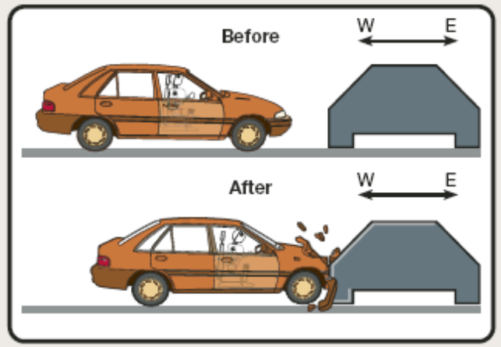

- When the vehicle crashes into the rigid barrier, it stops almost immediately. What does the law of inertia (Newton’s first law) predict about the motion of the passenger in the fraction of a second after the car collides with the barrier.
The passenger will move at 65 km/h unless they are wearing a seat belt

- Explain the importance of seat belts and air bags from the point of view of Newton’s first law.

49. The following diagrams show a crash test dummy sitting in the passenger seat of a vehicle. In this test, the vehicle and the crash test dummy are initially at rest; then the vehicle is struck from behind to simulate a rear-end collision.
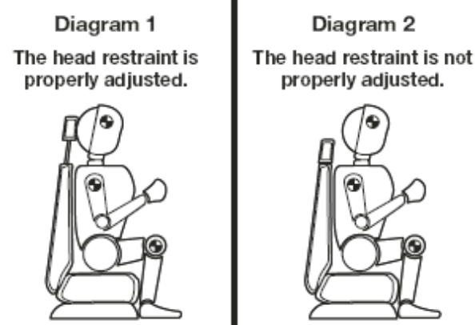

- In Diagram 1, the head restraint is properly adjusted – the centre of the head restraint is level with the top of the ears. Use Newton’s second law to describe the motion of the head and body if this seat is suddenly thrust forward.

- In Diagram 2, the head restraint is improperly adjusted – it is too low. In this case, the head is free to move somewhat independently of the body, constrained only by its attachment through the neck. Use the law of inertia (Newton’s first law) to describe how the head will tend to move even though the seat is accelerating the rest of the body.

- Explain why the injury caused by the scenario described in Diagram 2 is usually called whiplash.

APPLICATION:

    - A motorcycle and its driver have a combined mass of 224 kg. The engine generates an applied force of 1200 N, south, while the frictional forces exert 375 N, north. Let south be considered the positive direction for this question.
- Determine the acceleration of this motorcycle.

- Determine the time for this motorcycle to accelerate from rest to 65.0km/h south.

    - The following excerpt was taken from an operator’s handbook for motorcycles, mopeds, and power bikes. These are some of the suggestions given to drivers of these vehicles when carrying a passenger:
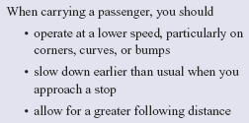

Use Newton’s laws of motion to explain the rationale for each of these driving suggestions.

